EXERCISE 1: Load NYC contagious disease data set
load NYCDiseases.mat; % Load the NYC disease data
EXERCISE 2: Create variables for various rows and columns
- Define a variable called mumps1942 that contains the case counts of mumps for the year 1942.
- Define a variable called measlesApril that contains case counts of measles for the month of April.
- Define a variable called chickenPoxSummer that contains the case counts of chicken pox for the summer months (June, July, and August).
>> mumps1942=mumps(12,:);
>> measlesApril=measles(:,4);
>> chickenPoxSummer=chickenPox(:,[6:1:8]);
EXERCISE 3: Plot mumps cases for 1942 in a new figure. Label your axes and gave a proper table title.
>> plot(mumps1942)
>> xlabel('Month')
>> ylabel('Cases')
>> title('Mumps cases in 1942');
EXERCISE 4: Plot mumps cases for 1942, rescaling y.
>> plot(mumps1942./1000)
>> xlabel('Month')
>> ylabel('Cases')
>> title('Mumps cases in 1942');
EXERCISE 5: Plot April measles cases, giving x values explicitly.
>> plot(years, measlesApril./1000)
>> xlabel('Month')
>>ylabel('Cases')
>>title('Measles cases in April');

EXERCISE 6: Plot mumps1942 and mumps1943 cases on same graph.
>> figure
>> hold on
>> plot(mumps1942./1000,'-sb')
>> plot(mumps(13,:)./1000,'-ok')
>> hold off
>> xlabel('Month')
>> ylabel('Cases')
>> title('Mumps cases in 1941 and 1942');
>> legend('1941','1942')
EXERCISE 7:
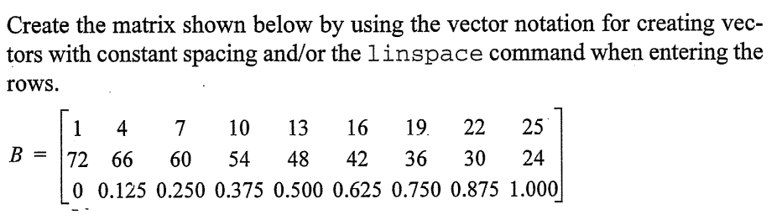
EXERCISE 8:
